**Game Design Document – Asunder**

**Table of Contents**

1. GENERAL INFORMATION

1.1 Basics

1.2 Target Audience

1.3 Themes

1.4 Summary

2. POSITION IN MEDIA AND GAMES HISTORY

2.1 Influences

2.2 Followed Trends

2.3 Unique Selling Points

3. NARRATIVE

3.1 Mode of Storytelling

3.2 Premise

3.3 Characters

3.4 Plot

3.5 World

3.6 Themes

4. GAMEPLAY

4.1 Structure

4.2 Goal

4.3 Winning / Losing Condition

4.4 Gameplay Loop

4.5 Abilities

4.6 Controls

4.7 Gameplay Example

4.8 Saving and Loading

5. USER INTERFACE

5.1 HUD

5.2 Menus

6. AUDIOVISUAL AESTHETICS

6.1 Art Style

6.2 Key Visual

6.3 Main Character

6.4 Game Logo

6.5 Music

7. TECHNICAL APPROACH

7.1 Software Used

7.2 Programming Language

7.3 System Architecture

8. THE TEAM

8.1 Team Info and Contact

**1. General Information**

**1.1 Basics**

Title: Asunder

Developer: Brain Drain Interactive

Question: How deep is your love?

Genre: Environmental puzzle game

Platform: Personal computer (PC)

Format: 3D, third-person perspective

**1.2 Target Audience**

Mid-core gamers

20 – 35 years old

Prefer implicit storytelling

Interested in games about the mind

Do not need to have a lot of leisure time

**1.3 Themes**

Reassembly

Self-acceptance

Dealing with past regrets

**1.4 Summary**

*Asunder* is a third-person, 3D puzzle game for PC about self-acceptance, taking place in the protagonist’s mind. Due to past regrets, their body has been shattered and they set on a journey to find and reassemble their missing pieces. Every reclaimed body part unlocks a new ability that is used to progress. The game is aimed at a mid-core audience in their twenties interested in implicitly told stories about mental phenomena.

**2. Position in Media and Games History**

**2.1 Influences**

*Severed* (cut-off body parts)

*Gris* (protagonist’s mind as game world)

*Journey* (implicit storytelling)

*Metroid Prime* (unlocking new paths in known areas)

*Ori and the Blind Forest* (new abilities unlocking new ways)

**2.2 Followed Trends**

Use of the protagonist’s mind as the setting of the game world

Focus on visual storytelling

Dealing with issues of mental health (specifically self-acceptance)

**2.3 Unique Selling Points**

Unique world design with different areas

Distinct art style and aesthetic

Developing, fragmented character design

Strong bond between theme, narrative, and gameplay

Subtle, implicit storytelling

**3. Narrative**

**3.1 Mode of Storytelling**

No text (written or spoken, except for title and team member names in the credits)

Visual design of the world

Tasks solved in gameplay

Memory shards found in each area

Related to past events and regrets of the protagonist

**3.2 Premise**

Game takes place in the mind of a broken person lacking self-acceptance

Lack of self-acceptance is related to past incidents where the main character burdened themselves with guilt

The protagonist has to heal themselves by working through memories related to a “loss” of a particular body part representing a flaw of the main character

**3.3 Characters**

Protagonist

No specified gender

Between 20 – 30 years old

**3.4 Plot**

Protagonist sets out to find and reassemble their missing body parts

They start with just their head, find the legs, then their torso, and finally their arms

With every found body part, they gain a new ability that helps them progress and unlock another area

At the end, they are able to leave their mind by using all abilities once more

**3.5 World**

Representation of protagonist’s subjective mind as a cave

Central hub with three distinct areas

Hub has a more distinct shape and looks more stable than the areas

Each area focuses on one aspect of their trauma and reflects it visually

Using all abilities, you are able to reach the exit of this world

**3.6 Themes**

Self-acceptance

Missing body parts as metaphor for broken mind

Confrontation with harmful memories and personal flaws

Need to be worked through in gameplay

Dealing with past regrets

Areas transport elements of memories visually

Gameplay connected to protagonist’s past failures

Reassembly

Literally on the level of character representation

Metaphorically by reviewing and accepting one’s own flaws instead of ignoring them

**4. Gameplay**

**4.1 Structure**

Linear structure

Central hub with temporarily inaccessible areas

Continuous world, no discrete levels

Three different areas

Predefined order of visiting them

In each one, a new body part and ability is gained

After visiting the last area, you’ll find a path from the hub to the final conclusion part

**4.2 Goal**

Find all body parts

**4.3 Winning / Losing Condition**

Win: Exit the mind world

Lose: No lose condition

**4.4 Gameplay Loop**

Enter area

Analyze environment

Solve puzzle(s)

Collect body part

Learn new ability

Unlock next area

**4.5 Abilities**

Move

Wall run (legs)

Build up speed to run up certain walls

Wind breath (torso)

Charge up to push away movable objects nearby

Hook shot (arms)

Aim at a solid surface nearby to be launched towards this location

**4.6 Controls**

Supported devices

Keyboard and mouse

Gamepad

Used device is detected once the game starts (no continuous detection)

Inputs

Move

Turn camera

Use breath

Use hook

Open / close pause menu

Control schemes

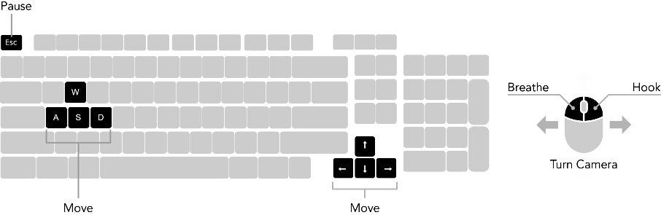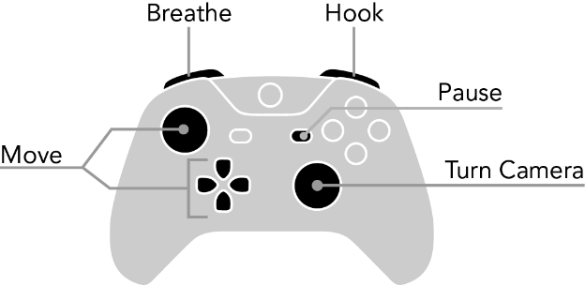

**4.7 Gameplay Example**

As the second area unfolds before me, I notice a huge scale in the center of the room. Approaching it, I notice that my character’s torso is laying atop a huge pile of documents on one side of the scale. Using my recently gained wall run ability, I climb my way up the mountain of documents to grab the torso. As I follow the instructions of an overlay prompting me to press a certain button, I notice I am now able to push away light objects nearby. The exit of the room is located way too high for me to reach. Maybe there is a way to raise this side of the scale by restoring the balance? Maybe I need to find something to move onto the higher side of the scale…

**4.8 Saving and Loading**

Game is saved automatically, no dedicated input or button to save

Game is saved when…

… a new area is entered

… a new body part was found

What is saved?

Current position of the player

Collected body parts

Found memories in each area

State of the areas

Settings

**5. User Interface**

**5.1 HUD**

Crosshair with different states for the hook shot

Not aiming at something solid

Aiming at something solid out of range

Aiming at something solid within range

No additional elements to let players focus on the game world

**5.2 Menus**

User interface without any text to match the mode of storytelling

Main menu

Continue

New game

Settings

Credits

Quit game

Pause menu

Continue

Settings

Quit game

**6. Audiovisual Aesthetics**

**6.1 Art Style**

Abstract, distinct

Simple, monochromatic characters

Each area has a unique visual theme

**6.2 Key Visual**

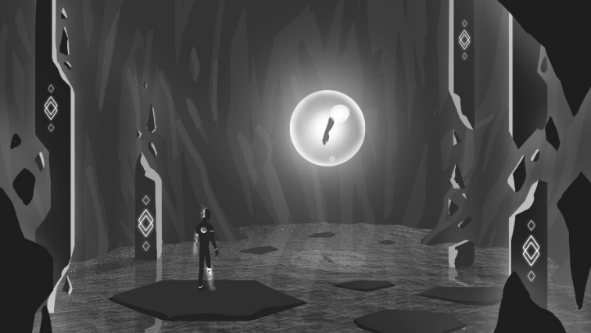

**6.3 Main Character**

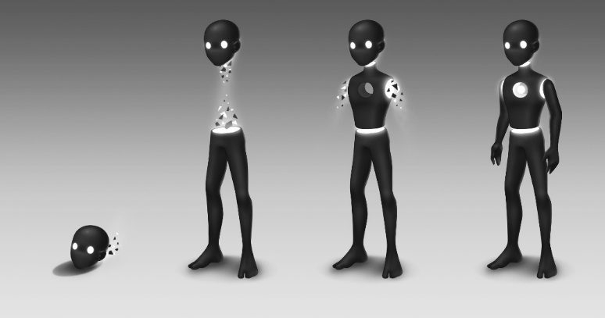

**6.4 Game Logo**

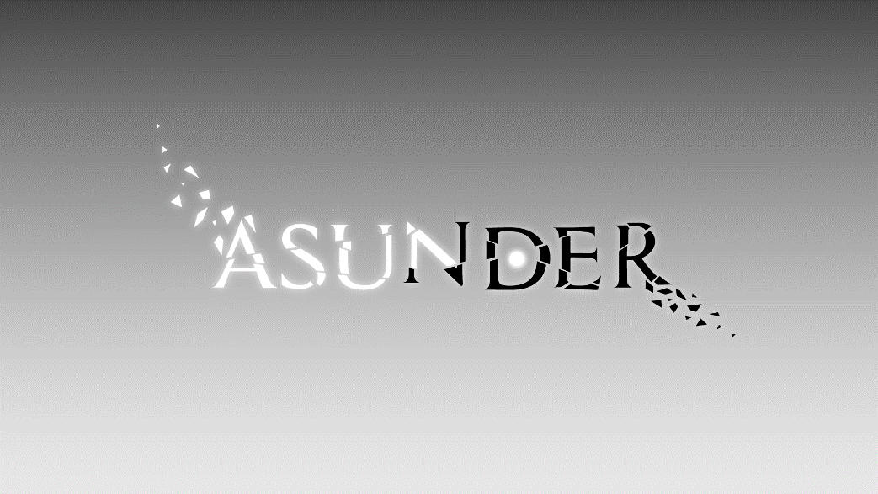

**6.5 Music**

Unique theme track for each area based on the core emotion of the related storyline

Title theme for the main menu, trailers, and gameplay videos to set the mood

Dynamic HUB theme that adjusts based on how many body parts were collected

Instrument layers are added

**7. Technical Approach**

**7.1 Software Used**

GitHub for source control

Unreal Engine 4

Version 4.22.2 (latest of today)

Communication tools

WhatsApp

Discord

Project management software

Hack‘n’Plan

**7.2 Programming Language**

Blueprints (visual scripting system of Unreal Engine)

**7.3 System Architecture**

Focus on decoupled systems

Use of Blueprint components for e.g. abilities, saving, or storing found memories

Two different character classes

One for the rolling head

One for the character with multiple found body parts

Based on the amount of body parts, the matching character class is spawned in

**8. The Team**

**8.1 Team Info and Contact**

Alexander Gerhards (Project Lead / Artist)

[alexander.gerhards@mailbox.org](mailto:alexander.gerhards@mailbox.org)

Trixia Quinzon (Artist)

[trixiaquinzon@gmail.com](mailto:trixiaquinzon@gmail.com)

Thiago Morano Gerding (Programmer)

[thiago.morano159@gmail.com](mailto:thiago.morano159@gmail.com)

Daniel Baracotti (Game Designer)

[daniel.baracotti@web.de](mailto:daniel.baracotti@web.de)

Lars Kalthoff (Game Designer)

[larskalthoff@web.de](mailto:larskalthoff@web.de)

